technogeeks


Basic Linux Command

asic Linux Commands

Command | Usage | Description
ls
 | ls /directory_path | List files
 | eg: ls /home/cloudera
cp | cp src_file_path
 | /destination_directory_path | Copy files
 | eg: cp student /home/cloudera/Desktop
 | mv src _file_path
 | /destination_directory_path | Renames a file or moves
mv | eg: mv myfile.txt /newdirectory | it from one directory to
 | eg: mv myfile.txt /newdirectory | another directory
 | mv current_filename new_filename
 | eg: mv computer.txt computer_hope.txt
 | rm file_path
rm |  | Delete files
 | eg: rm /home/cloudera/Desktop/file_name
 | cd /Directory_path | Change directory
Cd
 | eg: cd /home/cloudera/Desktop
pwd | Pwd | Print current directory
 |  | name or Present Working
 |  | Directory


www.technogeeksCS.com | +918600998107

technogeeks
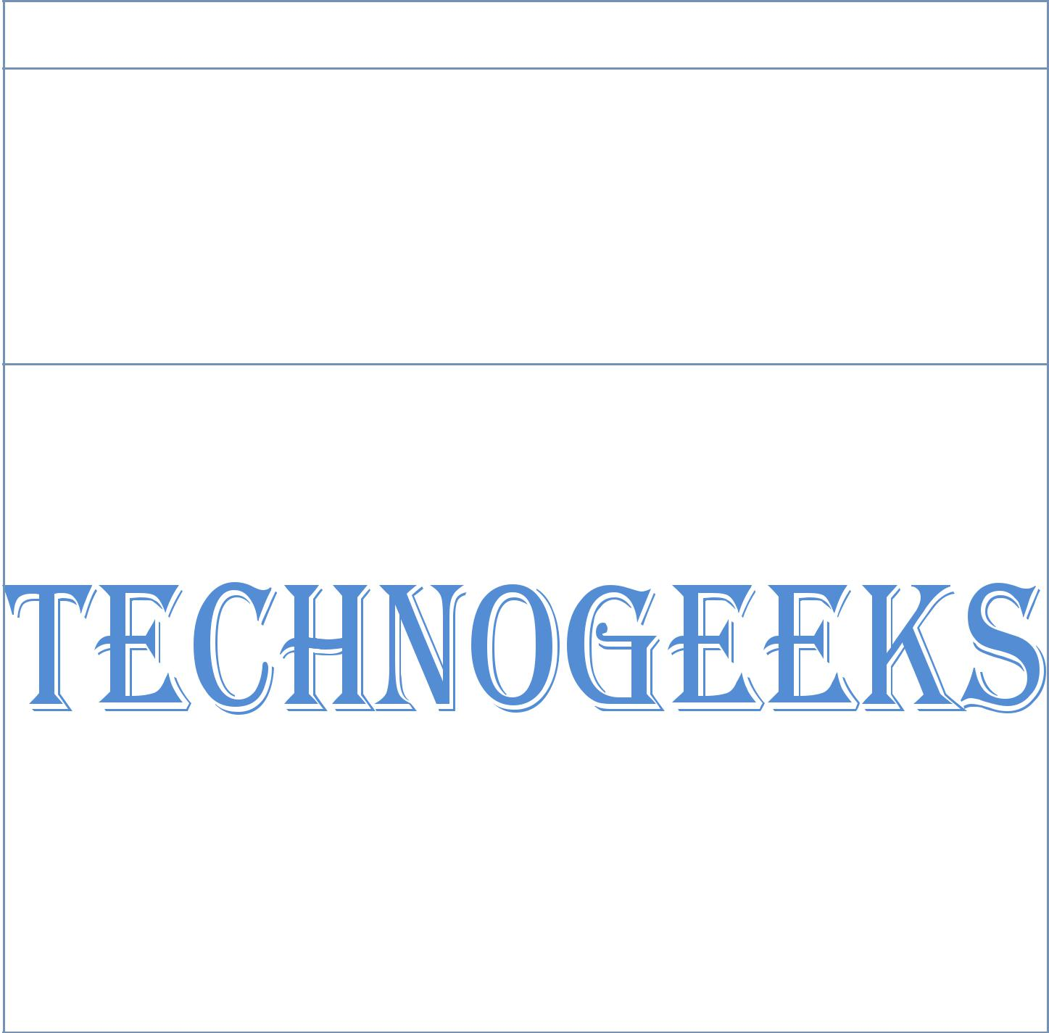

Command | Usage | Description

mkdir /new_directory_path

mkdir

eg: mkdir

/home/cloudera/Desktop/new_directory

Create directory

 |  | rmdir /directory_path
 | rmdir
 |  | eg: rmdir | Delete directory
 |  | /home/cloudera/Desktop/directory
 |  | cat /file_path
 | Cat |  | View files
 |  | eg: cat /home/cloudera/file_name
 |  | nl /file_path
 | Nl |  | Number lines
 |  | eg: nl studentRoll
 |  | gedit /file_path
 | Gedit |  | Text Editor
 |  | eg: gedit studentRoll

www.technogeeksCS.com | +918600998107

